ABSTRACT
The Illinois Junior Academy of Science
CATEGORY ____Human Behavior ____________ STATE REGION___#2__
SCHOOL ____Saint Constance School____________ IJAS SCHOOL # ___2062__
CITY/ZIP ___Chicago, IL 60630________________ SCHOOL PHONE _773-283-2311_
SPONSOR ___Ms. Dal Santo___________________________
NAME OF EXHIBITOR* _______Phillip Kaczor_______ GRADE ______8______
NAME OF EXHIBITOR _________Emilia Faber_______ GRADE ______8______
NAME OF EXHIBITOR ______________________ GRADE ____________
NAME OF EXHIBITOR ______________________ GRADE ____________
* If this project is awarded a monetary prize, the check will be written in this exhibitor’s name, and it will be his/her responsibility to distribute the prize money equally among all participating exhibitors.

PROJECT TITLE ________________The Stroop Effect_______________
Purpose: The purpose of this project is to investigate the stroop effect; when you try to name the color words are printed, it takes longer when the color word differs from the ink color than when the color word is the same as the ink color.

Procedure: Make Experimental and Control cards. Store the 2 decks in separate envelopes. Gather your volunteers in two groups, experimental and control. For each volunteer, instruct them on what they are supposed to do in the test. You will be given a set of cards where each card contains words printed in colored ink. The task is to call out the ink color of each ink word as quickly as possible without making a mistake. You will be given 2 sets total (one set at a time) Time how long it takes the volunteer to name the colors with the non-matching words (timing how long it takes them to go through a whole set).Do the same thing in step 4 but use the set of cards with the matching word. Repeat steps 5-6 with each volunteer, then collect your data.

Conclusion: The purpose of this experiment was to investigate the stroop effect. This was to test whether it takes longer to name the color of the word, when the color word differs from the ink color. The scientists predict that it will take longer for participants to name the color word when it differs from the ink color. The scientists’ hypothesis was correct. If the scientists would change something in their experiment they would use easier colors on the sets of cards. Some errors that occurred in the scientists’ project were how some of the volunteers did not listen to our instructions. At the end of the scientists’ experiment the average time for the control group was 15.74 seconds and 21.19 seconds for the experimental group. As the scientists’ predicted, it took longer to name the color of the word when it differed from the ink color.

SAFETY SHEET
The Illinois Junior Academy of Science
DIRECTIONS: The student is asked to read this introduction carefully, fill out the bottom of this sheet, and sign it. The science teacher and/or advisor must sign in the indicated space.

SAFETY AND THE STUDENT: Experimentation or research may involve an element of risk or injury to the student, test subjects and to others. Recognition of such hazards and provision for adequate control measures are joint responsibilities of the student and the sponsor. Some of the more common risks encountered in research are those of electrical shock, infection from pathogenic organisms, uncontrolled reactions of incompatible chemicals, eye injury from materials or procedures, and fire in apparatus or work area. Countering these hazards and others with suitable controls is an integral part of good scientific research.

In the box below, list the principal hazards associated with your project, if any, and what specific precautions you have used as safeguards. Be sure to read the entire section in the Policy and Procedure Manual of the Illinois Junior Academy of Science entitled "SAFETY GUIDELINES FOR EXPERIMENTATION" before completing this form.

The scientists will use adult supervision if needed
Participants and scientists will practice social distancing

SIGNED _________Emilia Faber________________Phillip Kaczor________________
Student Exhibitor(s)
SIGNED_______Ms. DalSanto________________________________________

HUMANS AS TEST SUBJECTS ENDORSEMENT
The Illinois Junior Academy of Science

THESE RULES WILL BE STRICTLY ENFORCED FOR THE STATE SCIENCE EXPOSITION. NO REGION SHOULD SEND A PROJECT TO THE STATE EXPOSITION THAT DOES NOT MEET THESE REGULATIONS.

Students and sponsors doing a human vertebrate project must complete this form. The signature of the student or students and the sponsor indicates that the project was done within these rules and regulations. Failure to comply with these rules will mean the disqualification of the project at the state level. This form must follow the Safety Sheet in the project paper.

1. Humans must not be subjected to treatments that are considered hazardous and/or that could result in undue stress, injury, or death to the subject.
2. No primary or secondary cultures taken directly (mouth, throat, skin, etc.) or indirectly (eating utensils, countertops, doorknobs, toilets, etc.) will be allowed. However, cultures obtained from reputable biological suppliers or research facilities are suitable for student use.
3. Quantities of food and non-alcoholic beverages are limited to normal serving amounts or less and must be consumed in a reasonable amount of time. Normal serving amounts must be substantiated with reliable documentation. This documentation must be attached to the Humans as Test Subjects Endorsement form. No project may use over-the-counter, prescription, illegal drugs, or alcohol in order to measure their effect on a person.
4. The only human blood that may be used is that which is either purchased or obtained from a blood bank, hospital, or laboratory. No blood may be drawn by any person or from any person specifically for a science project. This rule does not preclude a student making use of data collected from blood tests not made exclusively for a science project.
5. Projects that involve exercise and its effect on pulse, respiration rate, blood pressure, and so on are allowed provided the exercise is not carried o the extreme. Electrical stimulation is not permitted. A valid, normal physical examination must be on file for each test subject. Documentation of same must be attached to the Humans as Test Subjects Endorsement form.
6. Projects that involve learning, ESP, motivation, hearing, vision, and surveys require the Humans as Test Subjects form.

In this space, briefly describe the use of humans and assess the risk(s) to them in your project. Use the back of this page if necessary.

The scientists will be using volunteers; the volunteers will need to state the color a word is written in. There is minimal risk to the human beings in this science experiment. The scientists will be certain to:

- Select healthy human subjects for this test
- Practice social distancing and keeping the working space clean

The signatures of the student, or students, and sponsor below indicate that the project conforms to the above rules of the Illinois Junior Academy of Science.

_____Ms. DalSanto________________________ _________________Emilia Faber_____________
(Sponsor) (Student)

_____________1/25/2021_____________ __________________Phillip Kaczor_____________
(Date) (Student)

The Stroop Effect

Phillip Kaczor
Emilia Faber
St. Constance School
Grade 8

Table of Contents

Acknowledgements ………………………………... 1
Purpose…………………………………………..2
Hypothesis………………………………………….3
Review of Literature ………………………………... 4-8
Materials…………………………………………….9
Procedure……………………………………………...10
Results………………………………………………….11
Tables and Graphs………………………………………..12-16
Conclusion……………………………………………….17
Bibliography……………………………………………….18
Works Cited………………………………………………….19

Acknowledgments

The scientists would like to thank all the volunteers who participated in our project as well as Miss. DalSanto for guiding us through our experiment. Finally, the scientists would like to thank the judges that are grading our papers.

1

Purpose
The purpose of this project is to investigate the stroop effect; when you try to name the color words are printed, it takes longer when the color word differs from the ink color than when the color word is the same as the ink color.

2
Hypothesis
The scientists predict if they test the Stroop Effect on individuals then it will take longer for participants to name the color word when it differs from the ink color.

3
Ever come to an intersection and stop for traffic at a red light? Have you ever accidentally mistaken one word for another because it's not printed in black ink? There are common everyday occurrences that involve associating colors to certain words or actions. The Stroop Effect links both senses of vision and speech. The purpose of this experiment is to test whether it takes longer to name a color than when the word it differs from the ink color than when the word is the same color of the colored word.

The Stroop Effect
While it sounds simple, the stroop effect refers to the delayed reaction times when the color of the word does not match the color of the word. It’s easier to say the color of a word if it matches the semantic meaning of the word. For example, if someone asked you to say the color of the word “black” that was also printed in black ink, it would be much easier to say the correct color than if it were to be painted in green ink. The task demonstrates the effect the interference can have when it comes to reaction time. It was first described during the 1930’s by American psychologist John Ridley Stroop for whom the phenomenon is named. His original paper describing the effect has become one of the most famous, as well as one of the frequently cited in the history of psychology. The effect has been replicated hundreds of times by researchers. (www.verywellminded.com)

Eyes
The eyes are the sensory system's lungs. They provide animals with vision, the ability to acquire and process visual detail, as well as enabling several photo response functions that are
4
independent of vision. Eyes sense light and turn it in neurons into electro-chemical impulses. The eye is a complex optical structure in higher organisms that absorbs light from the external world, controls its intensity through a diaphragm, filters it to create an image through an adjustable assembly of lenses, converts this image into a series of electrical signals, and transmits these signals to the brain through complex neural pathways that links one eye to the other eye through the optic nerve. (www.medicalnewstoday.com)

Brain
The human brain is the control organ of the human nervous system. It controls most of the activities of the body, processing, integrating, and coordinating the information it receives from the sensory organs, and making decisions as to the instructions sent to the rest of the body. The amygdala is an almond shaped set of neurons located deep in the brain’s medial temporal lobe. The key of the amygdala is to process emotions. The midbrain serves important functions in motor movement, particularly movements of the eye, and in auditory and visual processing. The cerebellum receives information from the sensory systems, spinal cord, and other parts of the brain and regulates motor movements. The cerebellum coordinates voluntary movements such as posture, balance, coordination, and speech resulting in a smooth and balanced muscular activity. (www.britannica.com)

Reaction Time

Reaction Time may be defined as the time between a stimulus and a response. The signal
5
is perceived by the sensory system and the reaction evolves in the brain then runs through the spinal cord to the muscles, resulting in concentration. Concentration is the direction of one’s attention to a subject.

Nervous System
The nervous system is a highly complex part of a human that coordinates its actions and sensory information by transmitting signals to and from different parts of its body. The nervous system detects environment changes that impact the body, then works in tandem with the system to respond to such events. The central nervous system (CNS) is connected to the brain and spinal cord. It interrogates the received information and coordinates the activity of all parts of the body. Within the CNS, the international space is filled with a large amount of supporting non-nervous cells called neuroglial cells. The peripheral nervous system (PNS) consists of the nerves and ganglia outside the brain and spinal cord. The main function of the PNS is to connect the CNS to the limb and organs, essentially serving as a relay between the brain, spinal cord, and the rest of the body. Unlike the CNS, PNS is not protected by the vertebral column and skull, so it is exposed to toxins and mechanical injuries. (www.britannica.com)
Neurons
A neuron is an electrically excitable cell that communicates with other cells and that’s called synapse. It is the main component of the nervous tissue. Neurons are classified into 3 types based on their function. Sensory neurons respond to stimuli such as touch, sound, or light that affect the cells of the sensory organs, and they send signals to the spinal cord or brain. Motor neurons receive signals from the brain and spinal cord to control everything from muscle
6
contractions to glandular output. Interneurons connect neurons to other neurons within the same region of the brain or spinal cord. A group of connected neurons carries out a specific function like smell when activated. Axons and dendrites help the neurons as well. Axons are long slender projections of a nerve cell, in vertebrates, that typically conduct electrical impulses known as action potentials away from the nerve cell body. The function of the axon is to transmit information to different neurons, muscles, and glands. Dendrites are branched projections of neurons. They are protoplasmic extensions of nerve cells and operate as conductors of electrochemical stimuli received from neighboring cells. The impulses they receive are carried inwards and towards the some, or cell body. Most neurons have a lot of dendrites as well. (www.healthline.com)
Attention
Attention, in psychology, the concentration of awareness on some phenomenon to the exclusion of other stimuli. Attention is awareness of the here and now in a focal and perceptive way. Although human experience is determined by the way people direct their attention, it is evident that they do not have complete control over such direction. There are, for example, times when an individual has difficulty concentrating attention on a task, a conversation, or a set of events. At other times an individual’s attention is “captured” by an unexpected event rather than voluntarily directed toward it. Control and coordination of the many inputs and stored experiences and the organization of appropriate patterns of response are the province of the brain. The brain has impressive processing capabilities, but it has a limited capacity. (www.britannica.com)

7

Perception

The organization, recognition and analysis of sensory input in order to reflect and explain the information or environment presented is perception (from the Latin perceptio, meaning collecting or receiving). Both experiences require impulses that travel across the nervous system, culminating in the sensory system's physical or chemical stimulation. For instance, vision entails light hitting the eye's retina; scent is transmitted by odor molecules; and listening entails waves of pressure.Perception is not just the passive reception of these signals, but it is also affected by the awareness, recollection, anticipation, and interest of the recipient. Sensory feedback is a tool that transforms this low-level information into higher-level information. The mechanism that follows connects the ideas and desires of a person, restorative information. (www.britannica.com)

In conclusion, the Stroop Effect uses concepts of attention, reaction time, perception, and the nervous system. The brain and the sense of sight particularly are important in this experiment. Since all our senses are connected to our brain and signals are being deciphered every nanosecond, the Stroop Effect is considered a challenging test of perception, no matter your age, gender, or intellectual ability.

8

Materials
- 40 volunteers
- Stop watch
- 2 envelopes
- 30 index cards

9

Procedure

- Split the index cards into even piles having 15 in each pile.

- For the first pile of index cards write the color of the word that matches its actual color. So if you were writing in blue ink you would write the word “blue”. Do this 15 times using different colors. This will be the control deck.

- For the other 15 index cards write any color word in a different color than the actual word. So if you were writing “green” you would write it in purple ink.Do this 15 times using different color words and colors. This will be your experimental group.

- Store the 2 decks in separate envelopes.

- Gather your volunteers in two groups, experimental and control. For each volunteer, instruct them on what they are supposed to do in the test.
5a. You will be given a set of cards where each card contains words printed in colored ink.
5b. The task is to call out the ink color of each ink word as quickly as possible without making a mistake.
5c. You will be given 2 sets total (one set at a time)

- Time how long it takes the volunteer to name the colors with the non-matching words (timing how long it takes them to go through a whole set).

- Do the same thing in step 4 but use the set of cards with the matching word.

- Repeat steps 5-6 with each volunteer, then collect your data.

10

Results

The scientists predict that it will take longer for participants to name the color word when it differs from the ink color. The independent variables of this project are the set of cards that the volunteers had to read. The dependent variable is the amount of time it took to read the sets of cards.
The difficulties that the scientists faced were how some volunteers did not understand or follow the directions and it took them longer to answer.
If other people were to do the scientists’ experiment they would recommend putting easier colors on the cards, because many volunteers did not know the more difficult color names causing them to take longer to answer. The results of this project would most likely be the same to anyone who would try it.

11

Table & Charts

Person | Time (in seconds) it took to read Control Deck | Time (in seconds) it took to read Experimental Deck
1 | 23.13 | 17.38
2 | 22.31 | 21.21
3 | 10.46 | 16.78
4 | 24.58 | 31.45
5 | 15.59 | 20.32
6 | 11.13 | 18.71
7 | 18.13 | 26.60
8 | 18.38 | 20.43
9 | 15.65 | 18.15
10 | 14.46 | 28.78
11 | 9.71 | 12.43
12 | 18.41 | 16.81
13 | 12.93 | 19.13
14 | 15.10 | 17.33
15 | 15.01 | 20.85
16 | 11.20 | 23.50
17 | 14.18 | 23.52
18 | 13.76 | 22.95
19 | 10.28 | 18.51

20 | 13.33 | 24.42
21 | 10.13 | 15.51
22 | 20.55 | 31.58
23 | 13.76 | 17.93
24 | 13.03 | 23.50
25 | 11.18 | 17.88
26 | 13.00 | 19.52
27 | 18.41 | 16.56
28 | 13.95 | 28.32
29 | 11.71 | 19.73
30 | 20.28 | 23.96

13

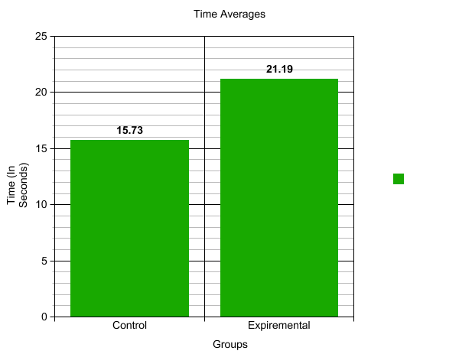

14

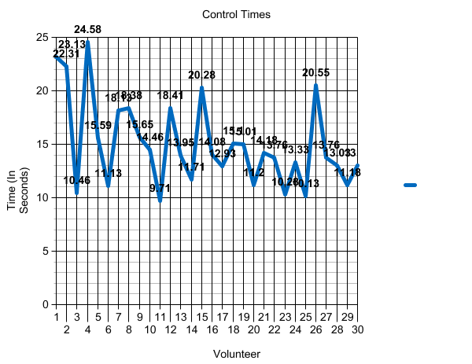

15
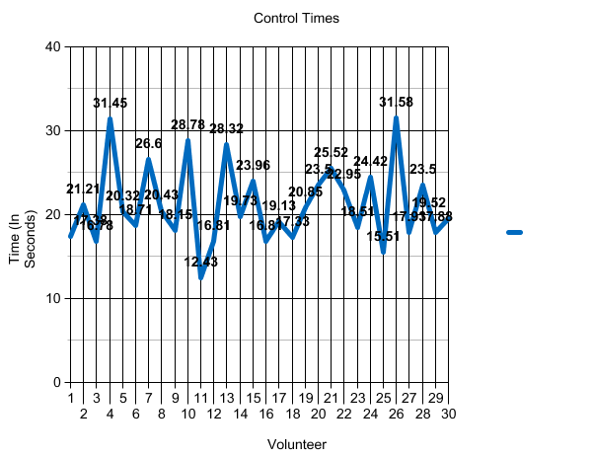

16

Conclusion

The purpose of this experiment was to investigate the stroop effect. This was to test whether it takes longer to name the color of the word, when the color word differs from the ink color.
The scientists predict that it will take longer for participants to name the color word when it differs from the ink color. The scientists’ hypothesis was correct. If the scientists would change something in their experiment they would
use easier colors on the sets of cards. Some errors that occurred in the scientists’ project were how some of the volunteers did not listen to our instructions.
At the end of the scientists’ experiment the average time for the control group was 15.74 seconds and 21.19 seconds for the experimental group. As the scientists’ predicted, it took longer to name the color of the word when it differed from the ink color.

17

Bibliography

Kendra, Cherry. “The Stroop Effect” verywellmind. May 25, 2020.
Dec. 16. https://www.verywellmind.com/what-is-the-stroop-effect-2795832
“Eye” Medical News Today. October 20, 2018.
Dec. 14. www.medicalnewstoday.com

Seunggu Han, M.D. — Written by Carly. “What Are Neurons?” Healthline July 20, 2018
Dec. 18. https://www.healthline.com/health/neurons

William Epstein. “Perception”. Britannica. Jan. 19, 2018.
Dec. 14, 2020.
https://www.britannica.com/topic/perception

18

Works Cited

By Kendra Cherry. “The Stroop Effect” Updated May 25,
https://www.verywellmind.com/what-is-the-stroop-effect-2795832
Accessed Dec. 16, 2020

“Perception”
https://www.britannica.com/topic/perception
Accessed Dec. 18, 2020

19

